WEB PROJECT PROPOSAL FOR ELEGANCE REBORN

NAME: BANDILE ZIKALALA
GROUP NO: 2
MODULE: WEB DEVELOPMENT
MODULE CODE: WEDE5020
INSTITUTION: ROSEBANK COLLEGE
DATE: 08 MARCH 2026

TABLE OF CONTENTS

PROJECT OVERVIEW……………………………………………………………………………..……3
MISSION AND VISION…………………………………………………………………………………3
TARGET AUDIENCE…………………………………………………………………………….………3
OBJECTIVES………………………………………………………………………………………….…..3
DESIGN REQUIREMENTS……………………………………………………………………….……3
KEY PERFOMANCE INDICATORS………………………………………………………….………4
PROGRAMMING LANGUAGE AND FRAMEWORKS………………………………………………………………………………………….4
DESIGN AND USER EXPERIENCE…………………………………………………………………………..……………….4
DESIGN AESTHETICS……...…………………………………………………………………………………….5-6
PROPOSE WEBSITE FEATURES AND FUNCTINALITY……………………………………………………………………………………..….6
TECHNICAL REQUIREMENTS……………………………………………………………………………………….7
PROJECT TIMELINE AND BUDGET………………………………………………………………..7
WEBSIE SITEMAP………………………………………………………………………………………8
REFERENCES ………………………………………………………………………………………….9

PROJECT OVERVIEW
Imagine stepping into a digital space that breathes sophistication, quality, and inclusivity. “Elegance reborn” is a modest clothing shop catering to women aged 20+, offering high-end, timeless pieces that evoke a sense of refined taste and understated luxury. That is “ELEGANCE REBORN”.
The purpose of the website is to create a professional e-commerce platform where customers can explore curated clothing collections, learn about the brand’s values, and purchase products online. A well-designed website enhances user engagement and improves the overall online shopping experience (Interaction Design Foundation, 2023)
MISSION AND VISION
MISSION: To provide high-quality, modest clothing that empowers individuals to express themselves with elegance and confidence.
VISION: To become a leading e-commerce destination for modest fashion, synonymous with quality, inclusivity, and timeless style.
TARGET AUDIENCE
DEMOGRAPHICS: Women aged 20+
PSYCHOGRAPHICS: Individuals seeking high-quality, modest clothing that exudes class and sophistication. “It’s giving quite money”.
OBJECTIVES
- To create an e-commerce platform showcasing modest clothing with a focus on quality fabrics, classic designs, and attention to detail.
- Provide an immersive experience that reflects the brand’s values of modesty, elegance, and inclusivity.
- Drive sales and build a loyal customer base through exceptional user experience and targeted marketing.

DESIGN REQUIREMENTS
- COLOUR SCHEMES: Earthy tones (beige, navy, charcoal), gold accents, and creamy whites to evoke luxury and elegance.
- IMAGERY: High-quality visuals showcasing models in understated, elegant settings, highlighting the clothing’s quality and craftsmanship.
- Typography: Seri fonts (Playfair Display, Georgia) for headings, sans-serif (Open Sans) for body text.
- Layout: Clean, minimalist design with ample white space, emphasizing product showcases and storytelling.
KEY PERFOMANCE INDICATORS
- CONVERSION RATE: Track % of visitors who make a purchase
- AVERAGE ORDER VALUE: Monitor average spend per transaction
- CUSTOMER RETENTION RATE: Track % of repeat customers
- WEBSITE TRAFFIC: Monitor unique visitors, page views, and engagement.
These metrics are commonly used to evaluate e-commerce website performance (Shopify, 2024)
PROGRAMMING LANGUAGE AND FRAMEWORKS
- FRONT-END: HTML5, CSS3, JavaScript
- BACK-END: PHP Node.js with Express.js
- E-COMMERCE PLATFORM: WooCommerce
- DATABASE: MySQL
DESIGN AND USER EXPERIENCE
- Responsive Design: Mobile-first approach, adaptable to all devices
- Navigation: Intuitive menu structure, clear categories, and search functionality
- UX: Streamlined checkout process, minimal friction, and clear CTA’s

DESIGN AND AESTHETICS
- Colour Schemes: Earthy tones, gold accents, and creamy whites
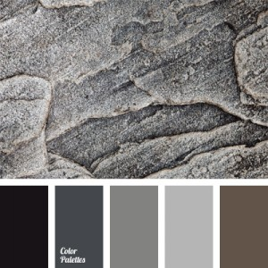
This Photo by Unknown Author is licensed under CC BY-NC-ND
This Photo by Unknown Author is licensed under CC BY-NC-ND
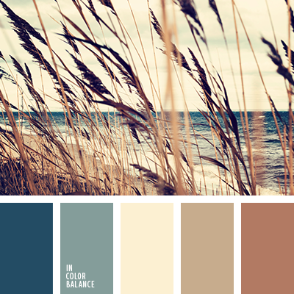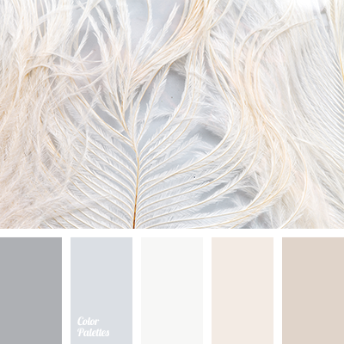
This Photo by Unknown Author is licensed under CC BY-NC-ND
This Photo by Unknown Author is licensed under CC BY-NC-ND
- Typography: Serif fonts (headings) and products and lifestyle shots
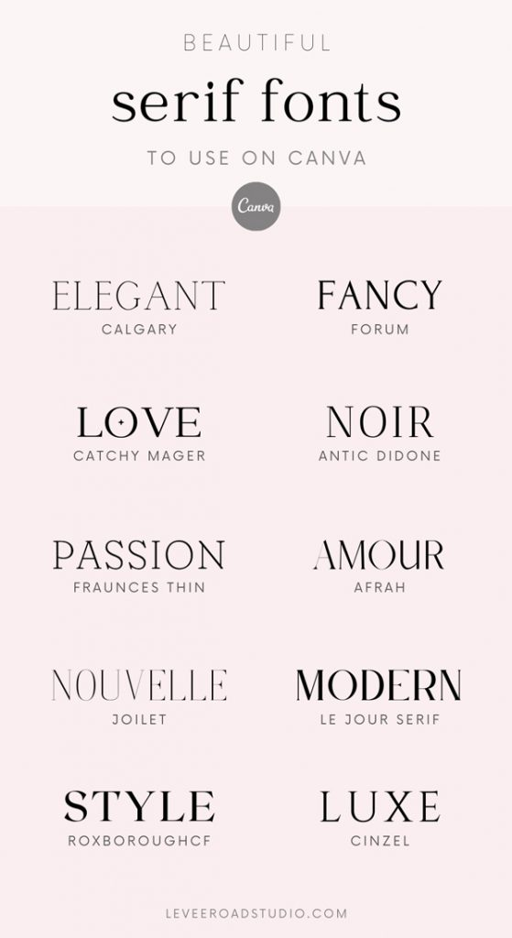
- Imagery: High-quality visuals showcasing products and lifestyle shots.
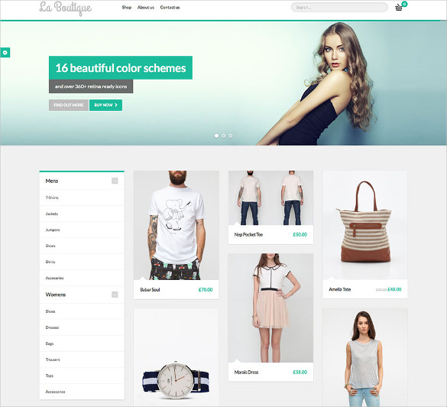
- Layout: Clean, minimalist design with ample white space
PROPOSED WEBSITE FEATURES AND FUNCTIONALITY
- Product Showcase: Categorized products with filters and sorting options
- User Accounts: Registration, login, and order tracking
- Payment Gateway: Secure payment processing (PayPal, credit cards, etc).
- Social Media Integration: Share products, follow us, and user-generated content
- About Us: Brand story, values, and mission
- Contact Us: Contact form, social media links, and customer support.

TECHNICAL REQUIREMENTS
- E-commerce Platform: WooCommerce
- Responsive Design: Adaptable to all devices and screen sizes
- Secure Payment Gateway: SSL encryption and PCI compliance
- Analytics: Google Analytics integration for tracking and insights.

PROJECT TIMELINE
The development of the Elegance Reborn website will follow a structured timeline to ensure that all phases of the project are completed. The project is expected to take approximately 6 weeks from planning to launch.
Week | Activities
Week 1 | Research & Planning Define project goals, research competitors, identify website requirements, create project plan
Week 2 | Design Planning Create wireframes, select colour scheme, typography, and overall layout
Week 3 | Front-End Development Develop website structure using HTML, CSS, and JavaScript
Week 4 | Back-End Development Configure database, implement WooCommerce functionality, and integrate payment systems
Week 5 | Testing & Optimization Test responsiveness, functionality, and fix bugs
Week 6 | Deployment & Launch Final adjustments, website deployment, and integration with analytics tools
This timeline ensures that the website is properly planned, designed, developed, and tested before its official launch.
PROJECT BUGET
ITEM | DESCRIPTION | ESTIMATED COST
DOMAIN NAME | Website domain registration | R 500.00 per year
WEB HOSTING | Hosting services for website storage and performance | R 1500.00 per year
WEBSITE DESIGN TOOLS | Design software or themes for development | R 1000.00
E-COMMERCE SETUP | Woocommerce plugins and payment gateway intergration | R 2000.00
MARKETING&SOCIAL MEDIA OROMOTION | Social media advertising and brand promotion | R 1500.00
CONTINGENCY COSTS | Additional unexpected costs | R 500.00
TOTAL ESTIMATED BUDGET: R 7000.00
This budget ensures that the website can be developed and maintained while maintaining professional quality and functionality.

WEBSITE SITEMAP
The website sitemap out lines the structure of ELEGANCE REBORN website and shows how different pages are connected. A clear sitemap ensures easy navigation and improves the overall user experience.

Home
│
├── Shop
│ ├── Women
│ ├── New Arrivals
│ └── Best Sellers
│
├── About Us
│
├── User Account
│ ├── Register
│ ├── Login
│ └── Order History
│
├── Cart
│
├── Checkout
│
└── Contact Us

REFERENCES
- Google, 2024. Google Analytics for websites. Available at:< Guides and videos - Analytics Help> [Accessed: 08 March 2026].
- Interaction Design Foundation, 2023. Responsive web design principles. Available at:< > [Accessed:08 March 2026].
- Shopify, 2024. Ecommerce metrics and KPI’s explained. Available at:< The Industry Leading Ecommerce SEO Guide (2025) - Shopify South Africa>[Accessed 09 March 2026].
- W3School,2025. HTML, CSS and JavaScript tutorials. Available at:<https://www.w3schools.com/jsref/default.asp>[Accessed 10 March 2026]
- WooCommerce, 2024. WooCommerce ecommerce platform. Available at:<https://woocommerce.com>[Accessed:10 March 2026.

